* PIR Sensor :-

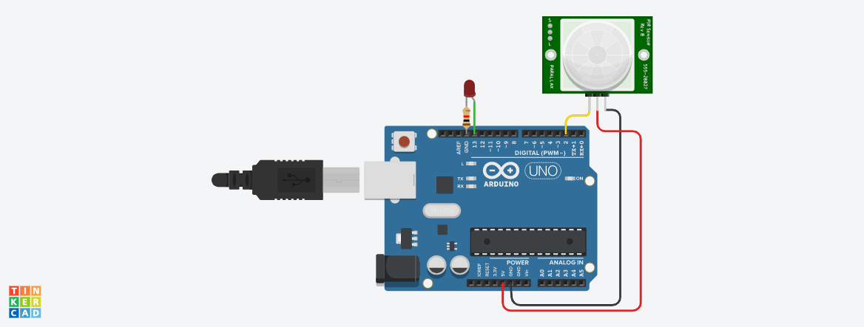

**Circuit diagram**

* **Description :-**

The objective of this project is to develop a motion sensor alarm based on a Passive Infra-Red (PIR). This project is aim to build a sensor system which is transmit and receive the signal. This project is about the motion detection using Infra-Red sensor in wirelessly. In short **when motion or vibration detect** then receive signal from them and this sensor pass signal to any type of output like sound, movement, flash etc.

* **Application :-** 
  + - * + Auto Open & Close Door System.
        + Automated Outdoor Lights, Garden, Parking Lights
        + Auto Lift Lobby Lights
        + Security System
* **Working Principle:-**

What is a PIR sensor? PIR or "Passive Infra-Red" sensor is a "Pyroelectric IR Sensor" which generates energy when exposed to heat. Everything emits some low level of radiation, the hotter the object is, the more radiation is emitted. When a human or an animal (with IR radiation wavelength of 9.4µMeter) approaches the sensors range the sensor detects the heat in the form of infrared radiation. The sensor only detects the energy emitted by other objects and don't produce any, that's why the sensor is called a PIR or "Passive Infra-Red" sensor.

* **Circuit Connection :-**

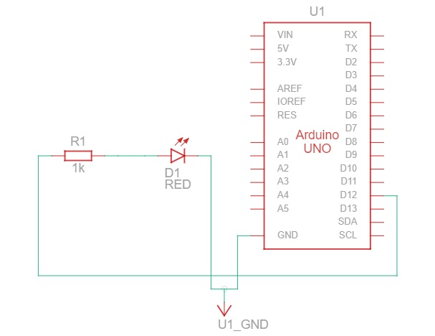

* Component List :-

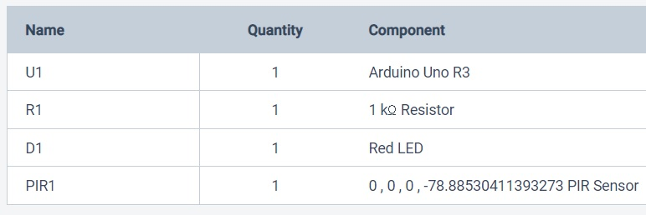

* **BLOCKCODES :-**

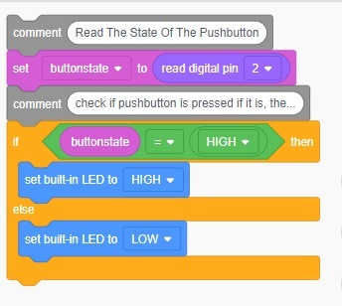

* **CODE :-**

// C++ code

//

int buttonstate = 0;

void setup()

{

pinMode(2, INPUT);

pinMode(LED_BUILTIN, OUTPUT);

}

void loop()

{

// Read The State Of The Pushbutton

buttonstate = digitalRead(2);

// check if pushbutton is pressed if it is, the...

if (buttonstate == HIGH) {

digitalWrite(LED_BUILTIN, HIGH);

} else {

digitalWrite(LED_BUILTIN, LOW);

}

delay(10); // Delay a little bit to improve simulation performance

}